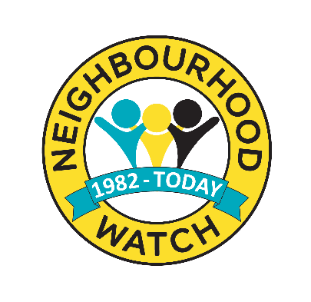
Framework for Local Police / Neighbourhood Watch Engagement

Local / Neighbourhood Policing Teams | Neighbourhood Watch Coordinators
Identify your Neighbourhood Watch Association lead https://www.ourwatch.org.uk/support/support-schemes/find-my-local-association  and Police Single Point of Contact | Identify your Neighbourhood Watch Association lead https://www.ourwatch.org.uk/support/support-schemes/find-my-local-association and Police Single Point of Contact
Identify your existing schemes and coordinators https://www.ourwatch.org.uk/get-involved/find-my-local-scheme  or contact your Neighbourhood Watch Association lead for information about schemes in your area | Ensure your scheme is registered on www.ourwatch.org.uk/joinNW and that it is mapped to show the area it covers
Make initial contact with your coordinators. Agree with them how best to keep this engagement going within the limitations of your time and commitments | Contact your local policing team (postcode search on police.uk) to let them know about your scheme and your contact details
Keep your coordinators informed about the crime and community issues in the area | Keep your members and residents informed about the crime and community issues in the area
Ensure your coordinators are aware how best to report crime, suspicious activity or concerns about vulnerable neighbours | Ensure your members and residents are aware how best to report crime, suspicious activity or concerns about vulnerable neighbours
Keep your coordinators updated with the result of investigations that affect their community (where appropriate) | Keep the police updated with any further information you become aware of in relation to reported crime in your area
Promote joining an existing Neighbourhood Watch scheme or starting a new scheme when engaging with residents – particularly when attending residential burglaries or other reports of neighbourhood crime | Promote joining your Neighbourhood Watch scheme or starting a new scheme when engaging with residents – particularly if you are aware of a residential burglaries or other reports of neighbourhood crime in your area
Share crime prevention advice with your coordinators | Share crime prevention advice with your members / residents
Share information about local crime prevention campaigns with your coordinators | Share information about local crime prevention campaigns with your members / residents
Invite your coordinators to participate in local crime prevention activities where appropriate. | Support local crime prevention activity in your area and encourage your members / residents to participate where appropriate.
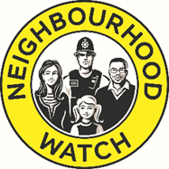
Police and Neighbourhood Watch Association Agreement

XXXX Police agree to: -

- Actively support and assist the XXXX Neighbourhood Watch Association and its members across XXXX.
- Nominate a strategic lead to have responsibility for supporting the development and implementation of Neighbourhood Watch across XXXX.
- Provide a single point of contact (SPOC) to liaise with the XXXX Neighbourhood Watch Association and the Neighbourhood Watch Network.
- Ensure that XXXX’s Neighbourhood Policing Teams forge and maintain links with Neighbourhood Watch Schemes and Scheme Coordinators.
- Provide timely and relevant information to the XXXX Neighbourhood Watch Association and XXXX Neighbourhood Watch Schemes.
- Consult with the XXXX Neighbourhood Watch Association on relevant issues that are likely to affect XXXX Neighbourhood Watch and its membership.
- Support the XXXX Neighbourhood Watch Association to promote Neighbourhood Watch and recruit new members.
- Put into place if not already, an information sharing protocol.

Signed on behalf of XXXX Force Area

Name: ___________________________________________________________________________

Position held within the Force: ________________________________________________________

In the presence of __________________________________________________________________

Position in XXXX Neighbourhood Watch: ________________________________________________

Date: ____________________________________________________________________________

Hertfordshire and some London Boroughs use https://www.owl.co.uk/ to register Neighbourhood Watch schemes
Hertfordshire and some London Boroughs use https://www.owl.co.uk/ to register Neighbourhood Watch schemes

