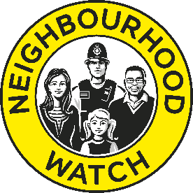

Neighbourhood Watch Network Community Grants
Application Form – Spring 2022

Thank you for your application. We appreciate your efforts in helping to make your community safer, more inclusive and vibrant. Please complete all questions on this form.

Tell us about your group

Association/Scheme/Group Name
Where is your group located? (please include county)
Contact Details of Main Applicant

Full Name

Email Address

Phone Number

Tell us about your project

Title of your project
Is this funding for a new project/activity?

Which of the Neighbourhood Watch Network’s funding priorities will your project support? | Funding priorities are:  - Crime prevention activities  - Community cohesion  - Enhancing the role of volunteers  - Improving the community environment and wellbeing  - Proactively engaging/involving people underrepresented in NW e.g. BAME, LGBTQ, people with disabilities, or young people’s voices (will require relevant safeguarding procedures to be in place)  [Please delete those that are not applicable]
Provide a brief overview of your project (no more than 400 words).

This should set out the activities you will undertake, how your project/activities benefit the local community and how it aligns with one or more of the listed funding priorities.

What outcomes do you hope to achieve with the project/activities and what difference/impact do you plan to see?

How will you measure and monitor the outcomes and impact?

What are the start and end date of your project/activities?

You will need to spend the grant by the end of 2022.
Who will be involved in the delivery of the project?

(e.g. Neighbourhood Watch members, wider community, local police, the council, other community charities or agencies?)

Amount of grant requested. This can be between £100 and £250.

Please ensure you submit a completed budget with your application.
Have you included this: Y / N

Please send your completed application form along with a completed budget for your project/activities in one email to fundraising@ourwatch.org.uk.
We can only accept applications by email at this time. If we need any further clarification about something in your application we may contact you either by email or telephone.
More information about Neighbourhood Watch Network Community Grants can be found at www.ourwatch.org.uk/communitygrants. If you have any difficulties completing this form or with any other aspect of the application process, please contact us at fundraising@ourwatch.org.uk.

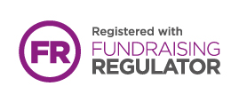

Neighbourhood Watch Network is a charity registered in England & Wales, CIO no. 1173349.

