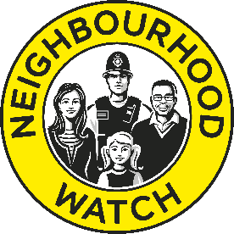

Neighbourhood Watch Network Community Grants
Application Form

Thank you for your application. We appreciate your efforts in helping to make your community safer, more inclusive and vibrant. Please complete all questions on this form.

Tell us about your group

Association/Scheme/Group Name
Where is your group located? (please include county)
Contact Details of Representative

Full Name

Email Address

Phone Number

Tell us about your project

Title of your project (basic description)
Which of the Neighbourhood Watch Network’s funding priorities will your project support? | Funding priorities are:  - Crime prevention  - Community cohesion  - Enhancing the role of volunteers  - Improving the community environment  - Engaging/involving young people’s voices  [Please delete those that are not applicable]
Provide a brief overview of your project (no more than 300 words).

This should set out the activities you will undertake, how your project/activities benefit the local community and how it aligns with one or more of the listed funding priorities.

What outcomes do you hope to achieve with the project/activities and how will these outcomes be measured and monitored?

What are the start and end date of your project/activities?

Your group’s work might be ongoing, but tell us how long this funding will last in relation to what you’re applying for.
Who will be involved in the delivery of the project?

(e.g. Neighbourhood Watch members, wider community, local police, the council, other community charities or agencies?)

Amount of grant requested. This can be between £100 and £500.

Please ensure you submit a completed budget with your application.

Applications will be accepted on an ongoing basis until 31st March and decisions made within 6 weeks of acknowledgment. Please send your completed application form along with a completed budget for your project/activities to fundraising@ourwatch.org.uk.
We can only accept applications by email at this time. If we need any further clarification about something in your application we may contact you either by email or telephone.
More information about Neighbourhood Watch Network Community Grants can be found at www.ourwatch.org.uk/communitygrants. If you have any difficulties completing this form or with any other aspect of the application process, please contact us at fundraising@ourwatch.org.uk.

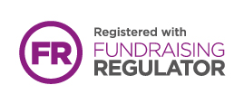

Neighbourhood Watch Network is a charity registered in England & Wales, CIO no. 1173349.

