Joining an existing Neighbourhood Watch scheme

Once you have joined as a member, you can join a scheme in your area/street. To find your local scheme to join, please click here to use our postcode checker.

Scroll down the page which appears. This brings you to the postcode checker. Enter your postcode here and click on SEARCH

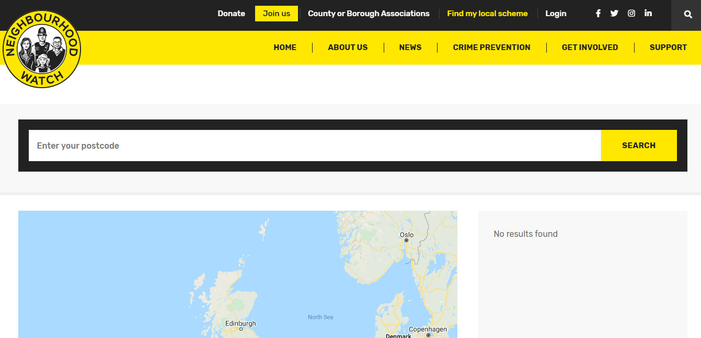

Then the nearest 7 schemes will be shown listed and on a map.

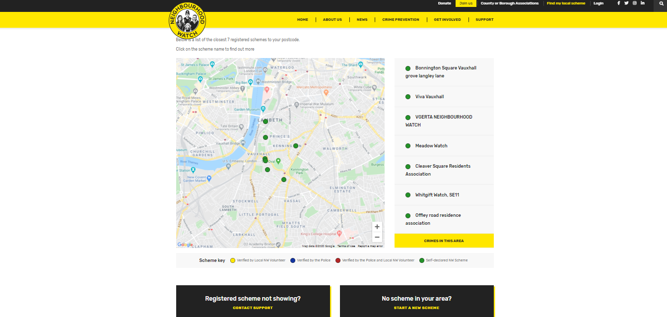

If you see the scheme you would like to join, then click on the scheme name on the right hand side. If you know of a scheme and it isn’t showing, please click on “Registered scheme not showing” box.

If there is no scheme for your area, have you thought of starting your own scheme or group of neighbours for that area? If that is the case, click on “No scheme in your local area?” box.

So you’ve found a scheme to join and you have clicked on the scheme, now what? The scheme details will appear and a coloured map showing the area. Click on “Login to join the scheme” box

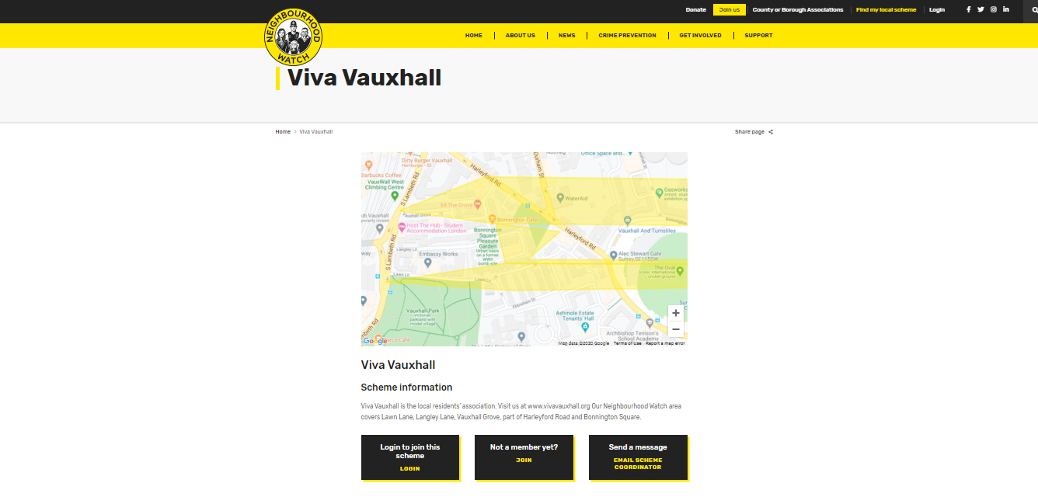

It will bring you into your member login area.

Sign in with your member details.

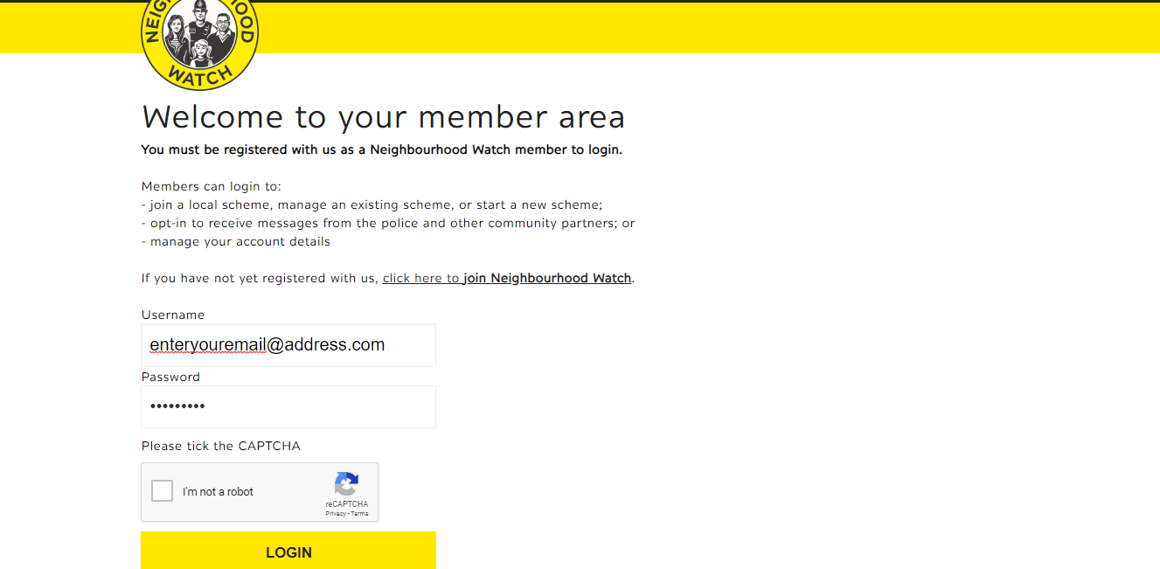

It will then bring you to your member area. Click on “Scheme Admin”

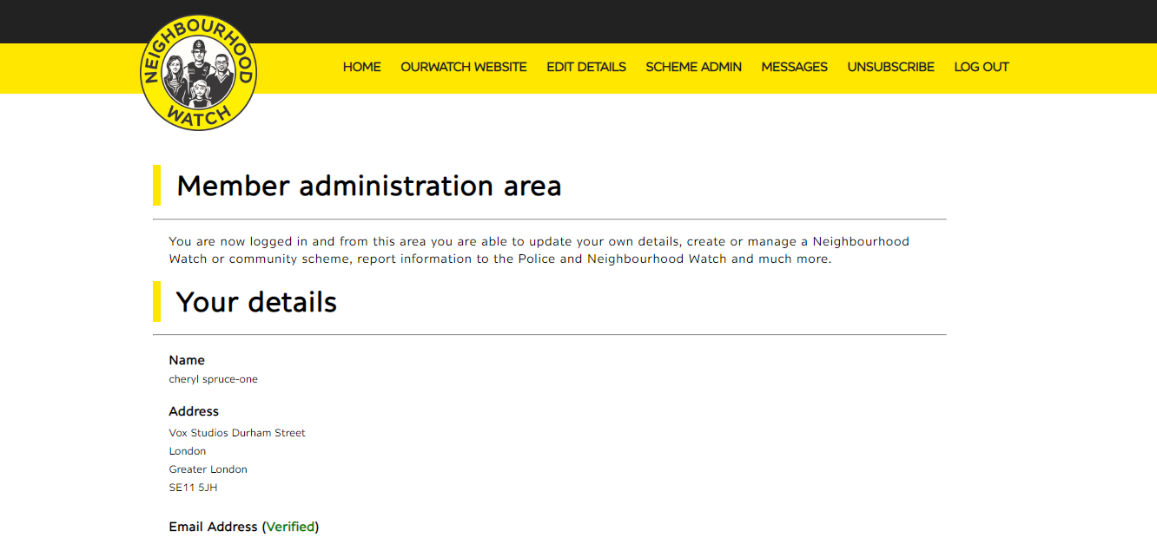

It will then bring you into the Scheme Admin page, Click on this box, for a list of schemes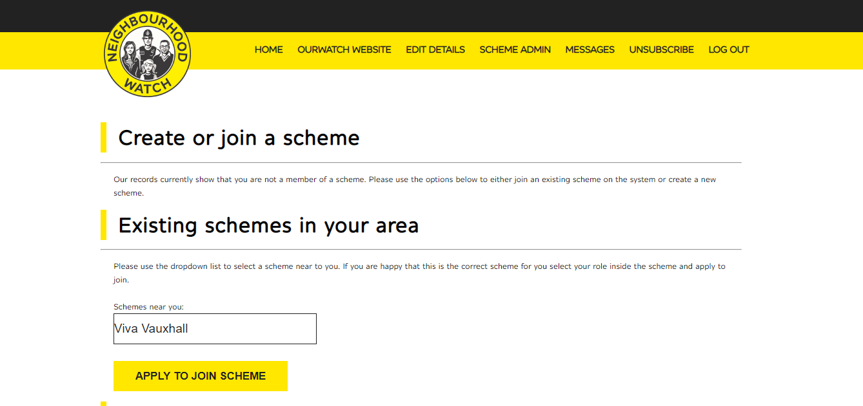

And then click to “Apply to Join Scheme”

Your application to join the scheme is complete and your street/area coordinator will be notified that a new person has applied to join their scheme.

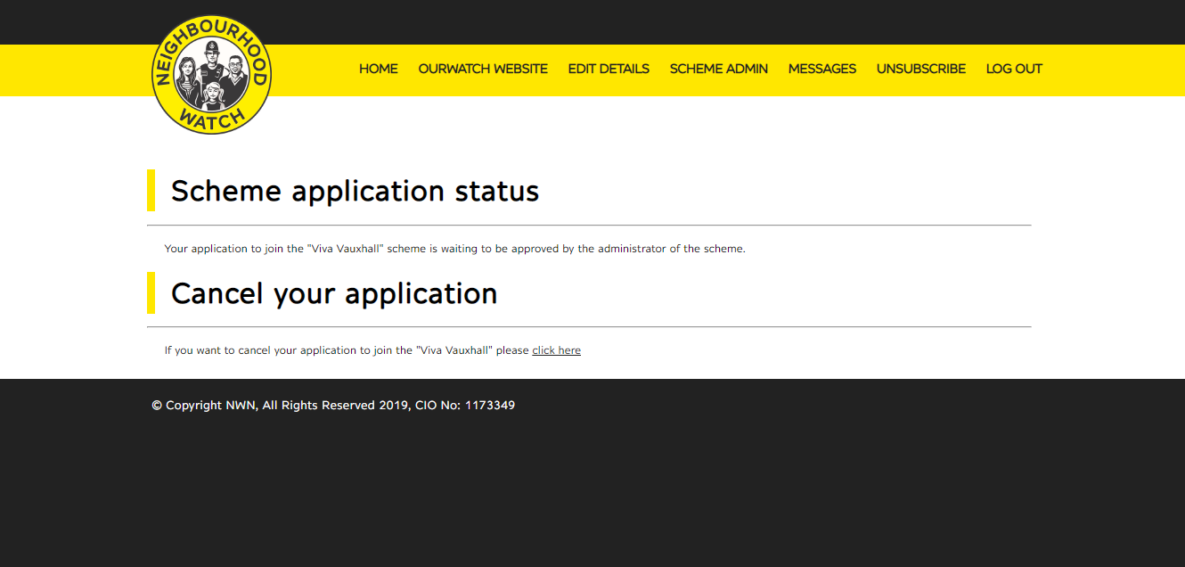

Thank you for signing up to a scheme/group in your area

