**Self-assessment tool case study: Cambridgeshire**

Cambridgeshire Neighbourhood Watch Association (CNWA) was one of the first areas to test the self-assessment tool. Robin Sutton, Chair of CNWA, said “The content fits in perfectly with the areas that I would like committee members to develop. It’s been an enormous confidence boost for me personally as a relatively new Chair.”

He circulated a copy of the tool to all the executive group to encourage and facilitate strategic thinking and start to identify what they feel is needed to improve aspects of NW across the force area together. The committee members were asked to complete the tool from their own perspective, with their responses generally showing a similar set of scores reflecting a few strengths and useful areas for improvement which are assisting to drive change in a number of areas. Comments from members who used the tool included – “nobody has asked these questions before” and “very thought provoking”.

Robin produced the analysis below of the results to show what CNWA are good at and what needs some work, both celebrating success and exploring ways of improving together.

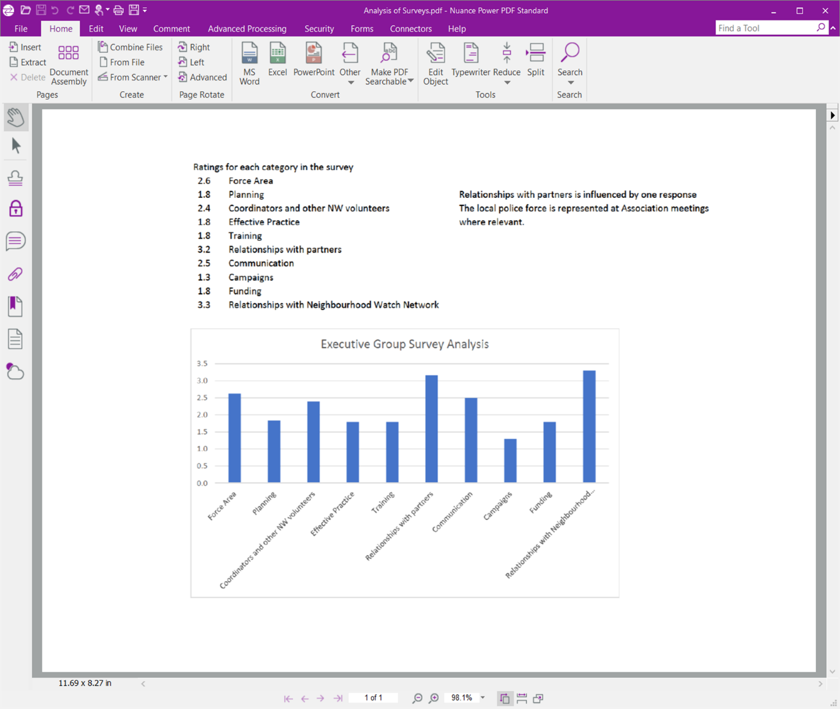

He has also circulated the tool to police partners and using their results to provide limited data triangulation in assessing specific NW issues and to support discussions about how they can help to improve the performance of NW in their districts.

Robin appreciates the flexibility that the tool gives him and is already thinking about different ways he might use the tool depending on the audience, issues in the area, whether there is a crime pattern locally, etc. This includes splitting it into focussed sections and looking at one aspect at a time or by just using the questions as a set of inspiration for discussions as appropriate for the situation. “I like being creative with the assessments. There is no measuring against a norm or criteria list, but it does encourage everyone to focus on improvement and change.”

“This self-assessment tool provides everyone in the organisation with a snapshot of how you do activities today and offers a mechanism to look at how you could do improved activities tomorrow, more effectively.”

In the longer term Robin hopes to be able to obtain both qualitative and some quantitative information to look at progress, appreciating that some improvements are a simple fix, while others require more drastic action and may take a number of years.