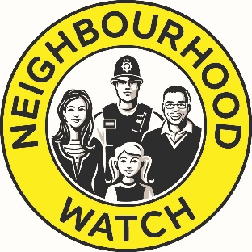
Neighbourhood Watch Coordinator/Deputy record sheet

Full name ………………………………………………………………………………………………………………………………………..
Address …………………………………………………………………………………………………………………………………………….
Email …………………………………………………………………….. Tel.no. ……………………………………………………….

Will you be a Coordinator or Deputy? (Please delete one)

Name of NW scheme: …………………………………………………………………………………………………………………….

Area /streets included: ..……………………………………………………………………………………………………………

Number of homes covered (approx.)……………………………………………………………………………………………….

You will be required to let Hampshire Police make a background check to assure us you are acceptable to be a coordinator/deputy. (No police information will be disclosed to NW)

Once confirmed as coordinator/deputy, your details will be kept in digital and/or paper format by the local NW Association / group or Area Coordinator and will be used to contact you with information relating to NW and community safety.
If no group exists, the data will be held by Hampshire NW Association

Your contact details will be shared with your local police team but no other third party without your permission. You have the right to see the data that is held, change it or ask for it to be deleted.

You will be required to register yourself and your scheme on the National NW database using
www.HampshireAlert.co.uk or www.ourwatch.org.uk -there you can see and change your data.

Sign………………………………………………………. Date ……………………………………………………………

Give this completed sheet to your Area Coordinator or local Association or group. If these do not exist then please send it to the secretary of the Hampshire NW Association at hinwa.sec@gmail.com

