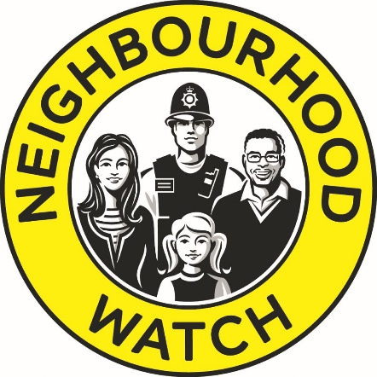

Neighbourhood Watch Network Complaints Policy

Issue No: 1.0
Last Review: April 2019
Review Due: April 2021

Introduction
At Neighbourhood Watch Network (NWN) we always aim to treat all our members and supporters with the highest level of care and respect. When a complaint is received it will be logged and investigated promptly.
NWN seeks to constantly improve its service to members and supporters and ensure our policy adheres to best practice. Therefore, we regard complaints as an opportunity for us to reflect on our processes and practices and see if there are opportunities for us to strengthen and improve them. However, on occasion we recognise that we may not meet our high standards.
NWN is regulated by the Fundraising Regulator (FR), the independent regulator of charity fundraising. The FR sets and promotes the standards for all fundraising activity, known as the “Code of Fundraising Practice”. For more information on the FR, please visit their website, www.fundraisingregulator.org.uk.

Definition of a complaint
We define a complaint as a situation or instance where either an individual or organisation, considers that NWN has fallen short of their reasonable expectations and wishes to express their dissatisfaction. A complaint can be communicated to NWN by any channel including, telephone, mail, email, social media or in person.
Neighbourhood Watch Network
Unit 18, 8th Floor, Elizabeth House
39 York Road
London
SE1 7NQ
Email: enquiries@ourwatch.org.uk
Telephone: 0116 402 6111

NWN’s Complaints Process
We take all complaints very seriously and aim to resolve complaints quickly, fairly and effectively. We promise to deal with your complaint sensitively.
We will acknowledge your complaint, no later than two working days after receipt. Wherever possible, we will provide a full resolution to your complaint at the same time.
Where your concerns require us to undertake further investigations, and we are not able to provide a full resolution as part of our initial response, we will, within two working days after receipt, provide you with an expected timescale for our response as part of your acknowledgement and keep you up-to-date at regular intervals throughout our investigations. Where this is the case, we will also tell you who is managing your complaint so you have a point of contact should you need to get in touch with us. In any event, you should expect to receive a full response from us at the earliest opportunity and no later than 20 working days from the date we received your complaint.
In order to assist us with your enquiries, please provide your contact details and explain your concerns as clearly and fully as possible. There may be some occasions where we need to ask you for more information to investigate your concerns fully and, if this is the case, your kind response will enable us to resolve your complaint as promptly as possible.
We really hope that we are able to resolve your complaint in an honest, open and satisfactory way. However, if you are still unhappy you can request that your complaint be escalated to the Charity’s Board of Trustees who will review your concerns and the initial outcome before responding to you fully.
Following this, if you remain dissatisfied you can get in touch with either the Fundraising Regulator, if your complaint is about fundraising, or the Charity Commission, for other areas of our work.
Their contact details are below:
Fundraising Regulator
2nd Floor
CAN Mezzanine Building
49-51 East Road
London
N1 6AH
www.fundraisingregulator.org.uk
Tel: 0300 999 3407
Email: enquiries@fundraisingregulator.org.uk

The Charity Commission
PO Box 211
Bootle
L20 7YX
Tel: 0300 066 9197
www.gov.uk/government/organisations/charity-commission

Your Information
In order to manage our complaints process effectively, we maintain a log of all complaints raised, including information about you as the complainant. If you would like further information, or have any concerns, about the information we may hold about you in this regard, please refer to our Privacy Policy or speak with a member of our Central Support Team.

