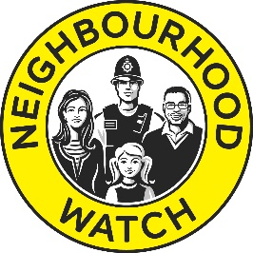
Neighbourhood Watch
Registration & Consent form

Thank you for joining Neighbourhood Watch.

The below information will be used by your local Neighbourhood Watch Coordinator and/or Area / District Neighbourhood Watch Association to administer your Neighbourhood Watch Scheme and send you crime prevention messages and information and newsletters relevant to the work of Neighbourhood Watch.
With your consent, it will also be shared with the Neighbourhood Watch Network to send you newsletters, crime prevention information from our partners and information and the occasional survey relating to the work of Neighbourhood Watch nationally. In this case your details will be entered onto the national Neighbourhood Watch Scheme Register which is processed on our behalf by Visav Ltd.
Any information you give below will not be shared with anyone else or used for any other purpose without your explicit consent.

Please complete in BLOCK CAPITALS the details below and return to your Neighbourhood Watch Coordinator or alternatively register to join your local Neighbourhood Watch Scheme on the OurWatch website www.ourwatch.org.uk.

Title and full name: _____________________________________________________________________

Date of birth (optional): _______________________Ethnicity optional) ________________
Home address: ________________________________________________________________________
_________________________________________ Postcode: ___________________________________
Home phone (optional): ____________________ Mobile: (optional) ____________________________
Please tick if you agree
E-mail address:

- I agree for Neighbourhood Watch to use my details for Neighbourhood Watch purposes outlined above.
- I agree to receive messages and newsletters from my local Neighbourhood Watch scheme in (force area).
- I agree for my details to be added to the national Neighbourhood Watch Scheme Register and to receive messages and newsletters from Neighbourhood Watch Network.

Signed: __________________________________ Date: __________________________________

If, in the future, you wish to update the details you have given above or have your data removed from Neighbourhood Watch records please contact ……………………………….. , or log into your account on the Ourwatch website (if you have one) https://www.ourwatchmember.org.uk/.

My preferences to contact me are: Post ☐ Email ☐ Telephone ☐ Text message ☐

